Power BI Module End Project
AI-Powered Fleet Performance & Delivery Efficiency Dashboard
1. Data Cleaning & Modelling:
- Fix missing fuel consumption values (use mean imputation).
Calculate the average value in Power Query and use it to replace all null values.
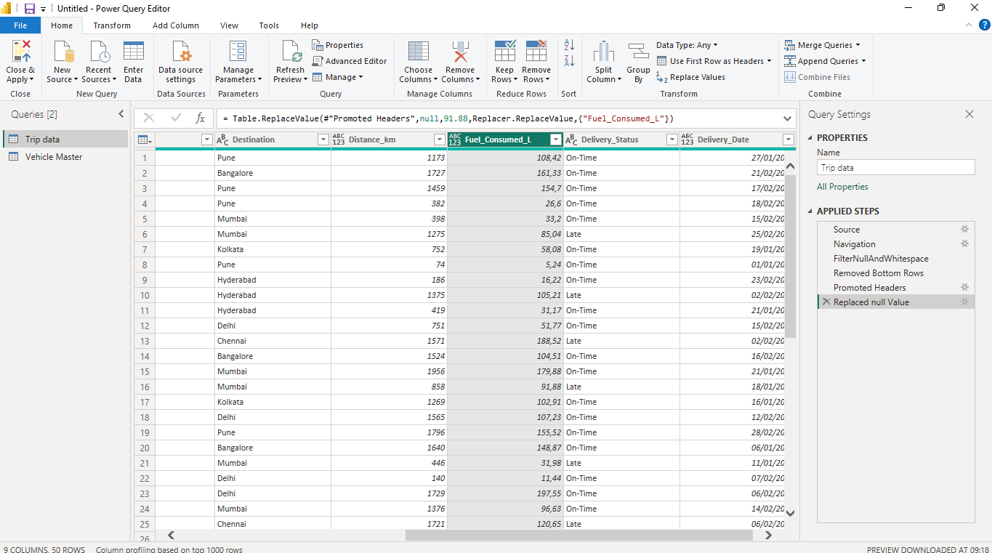
- Create a relationship using Vehicle_ID between Trip_Data and the Vehicle Master table.
Merged Trip_Data with Vehicle_Master using a Left Outer Join on Vehicle_ID to bring the corresponding Vehicle_Type into the Trip_Data table.
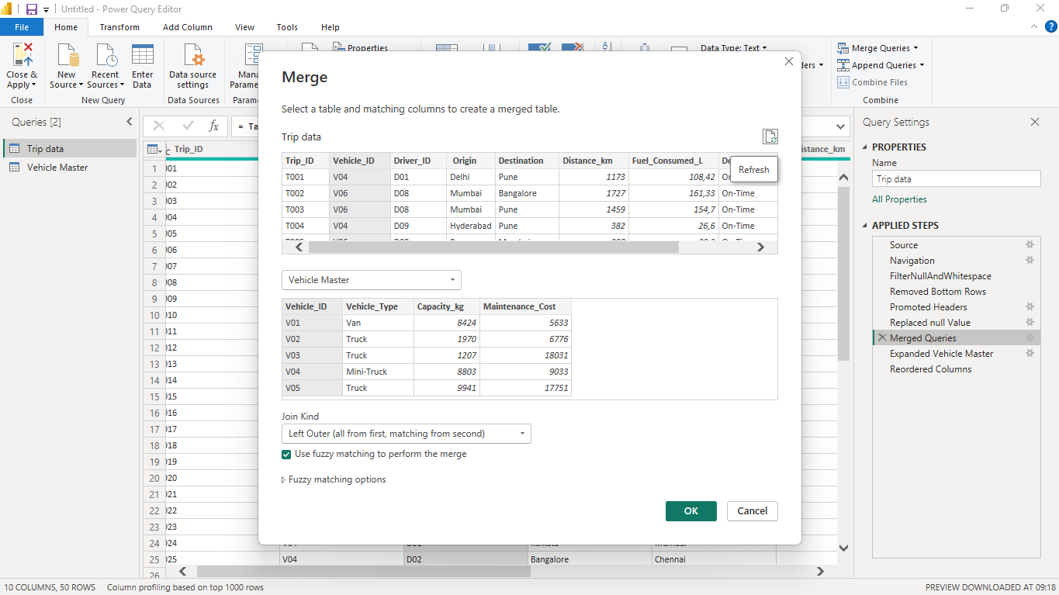
2. DAX Measures:
Fuel Efficiency = Distance / Fuel Consumed:
Ensured that the Fuel_Consumed_L column had correct decimal formatting and Execute the DAX Formula.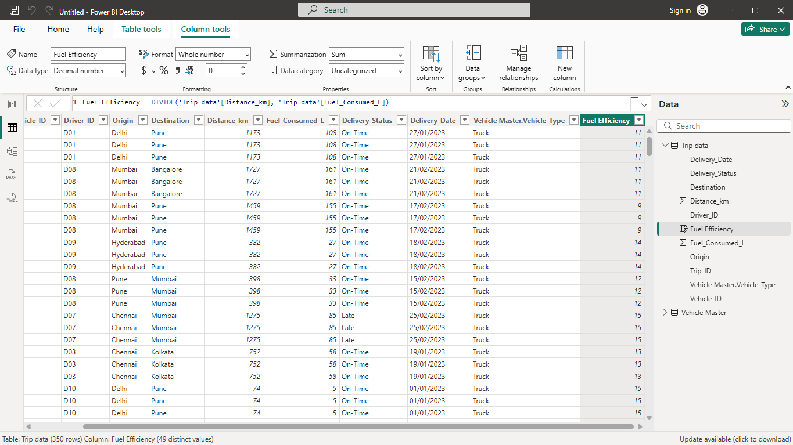
On-Time Delivery % = On-Time Trips / Total Trips:
Calculated how many trips were on time, and total trips, and displayed the calculated on-time delivery percentage using card visuals in Power BI.
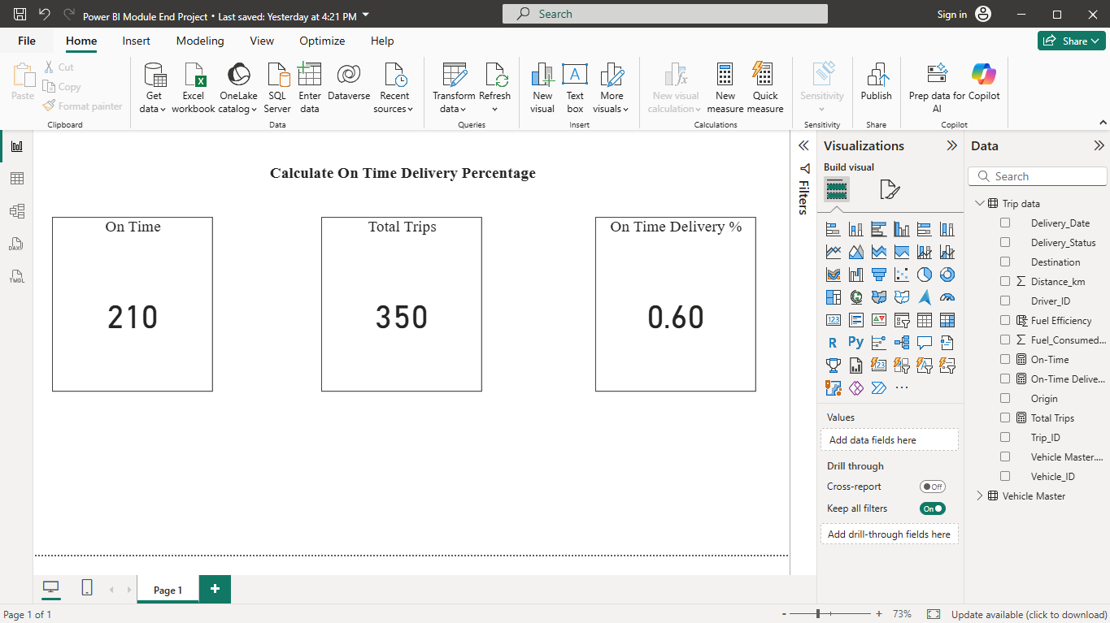
Cost per km = (fuel cost + Maintenance Cost) / Distance:
Created a new calculated column to find the cost per km for each trip.
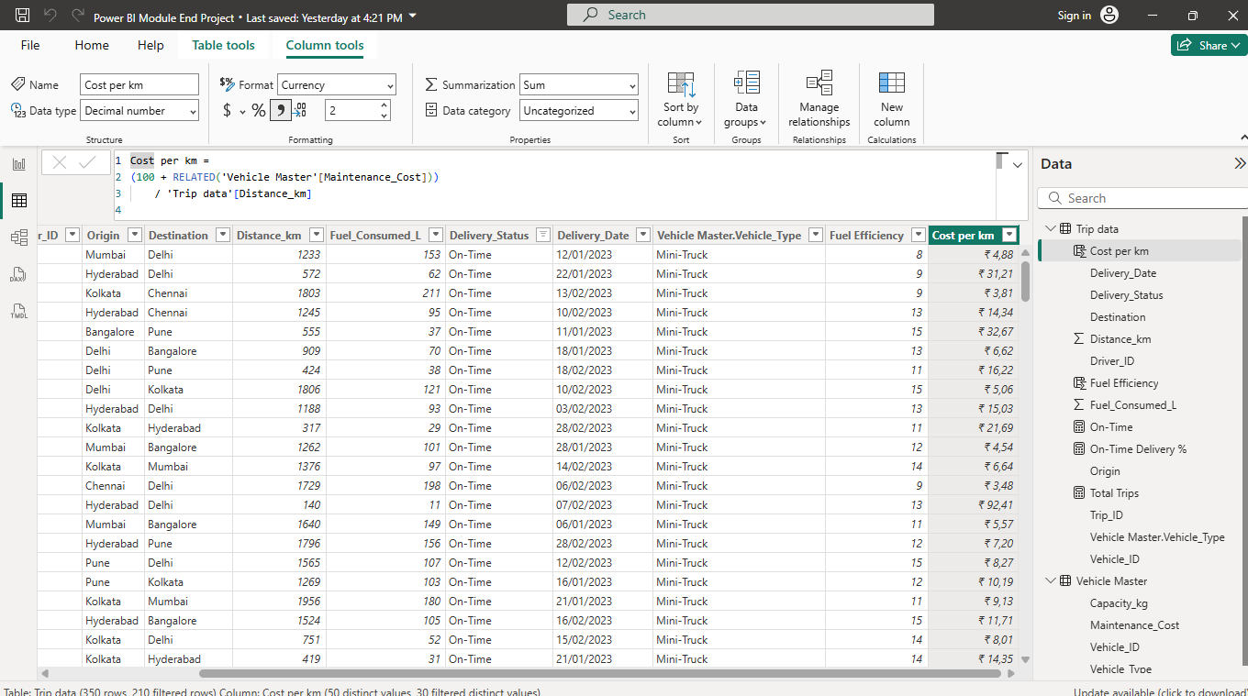
3. Visualization:
○ Bar chart: On-Time Delivery % by Destination.
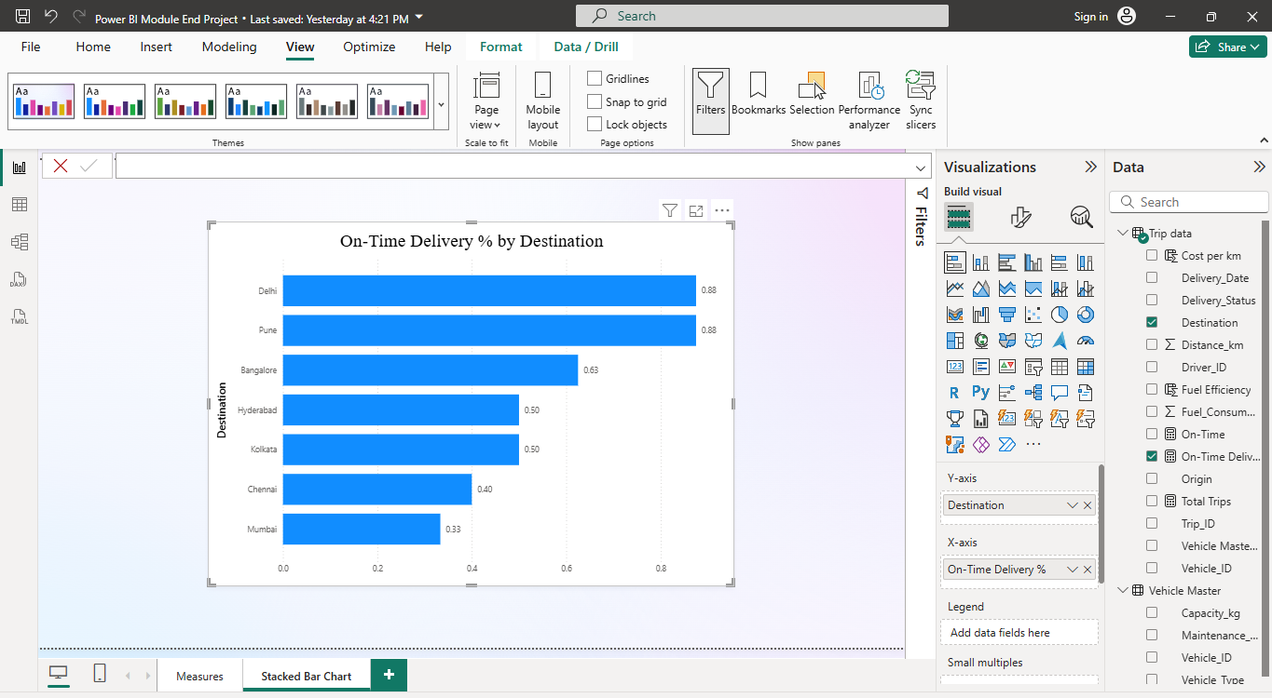

○ Line chart: Fuel efficiency trend by delivery date.
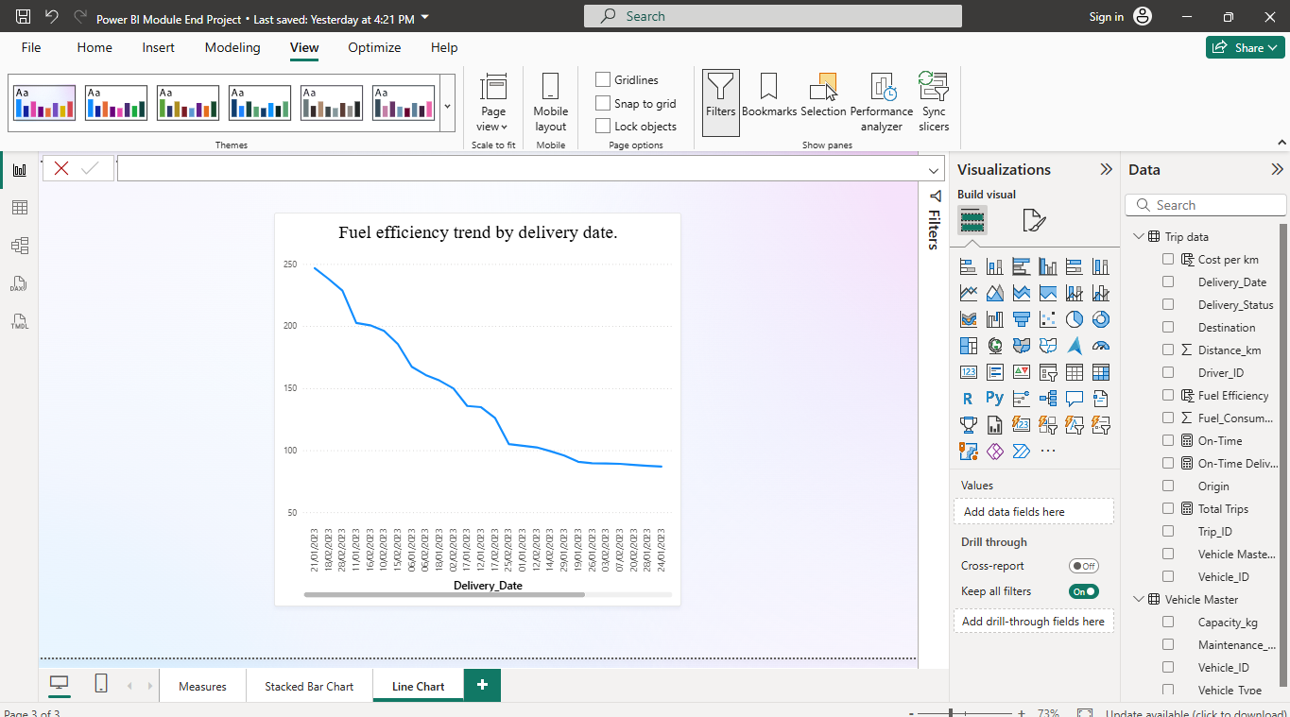
Cards visualization:
■ Avg. Delivery Time
■ Average cost per km
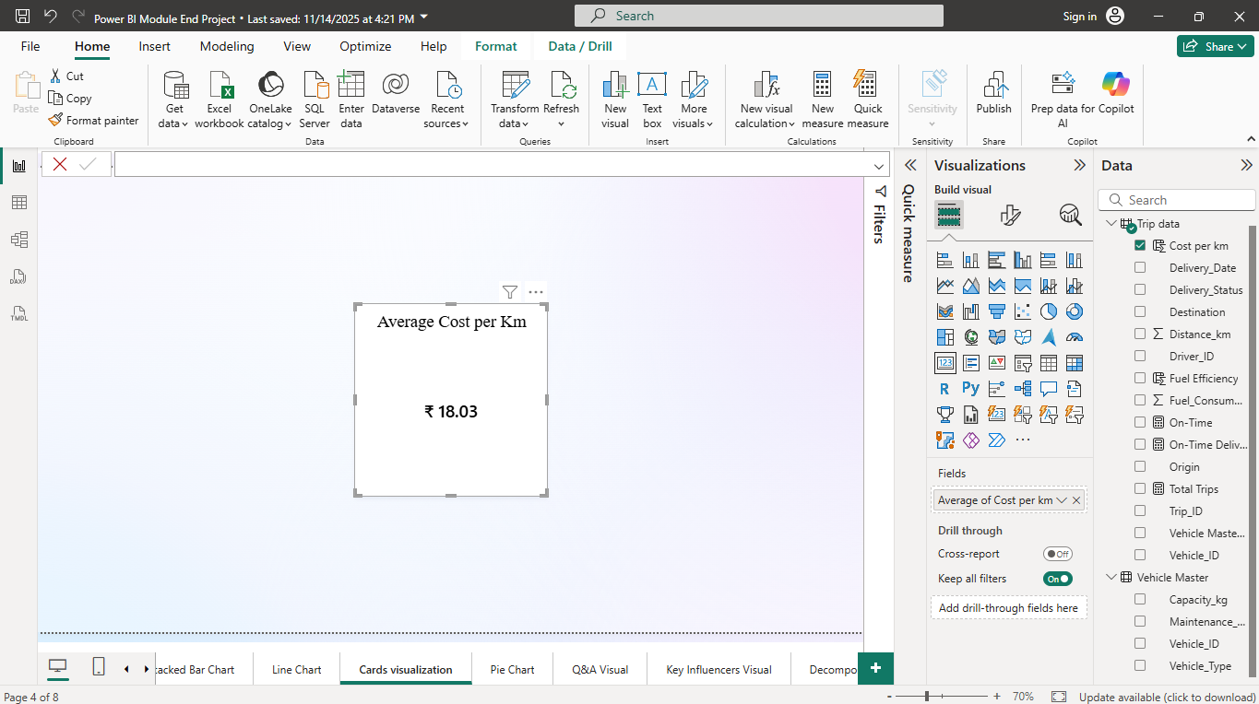

○ Pie chart: vehicle type vs Average maintenance cost
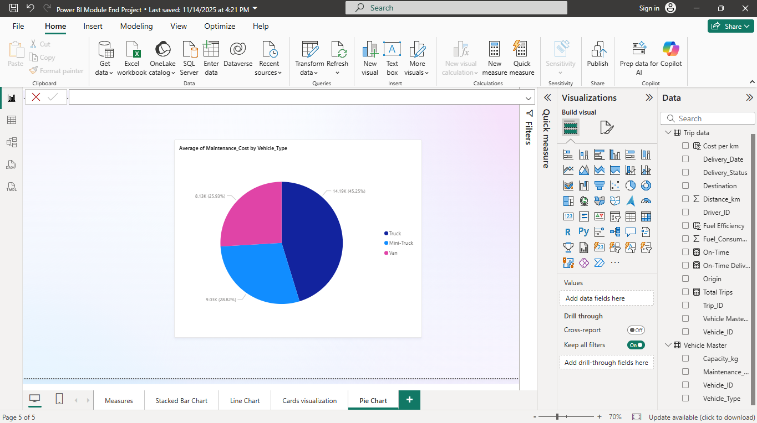❖ Q&A Visual:
➢ Add Q&A visual → Prompt: “Average Cost per km by vehicle type?
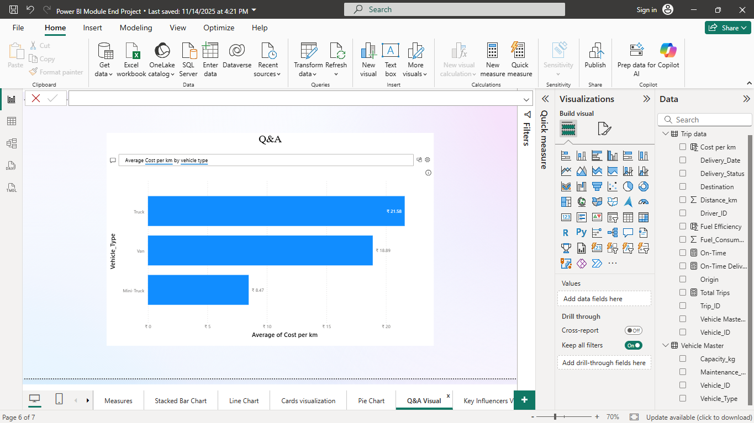

❖ Key Influencers Visual:
➢ Add Delivery Status in the Analyze and explain by -distance in
km,vehicle_type, Driver_ID
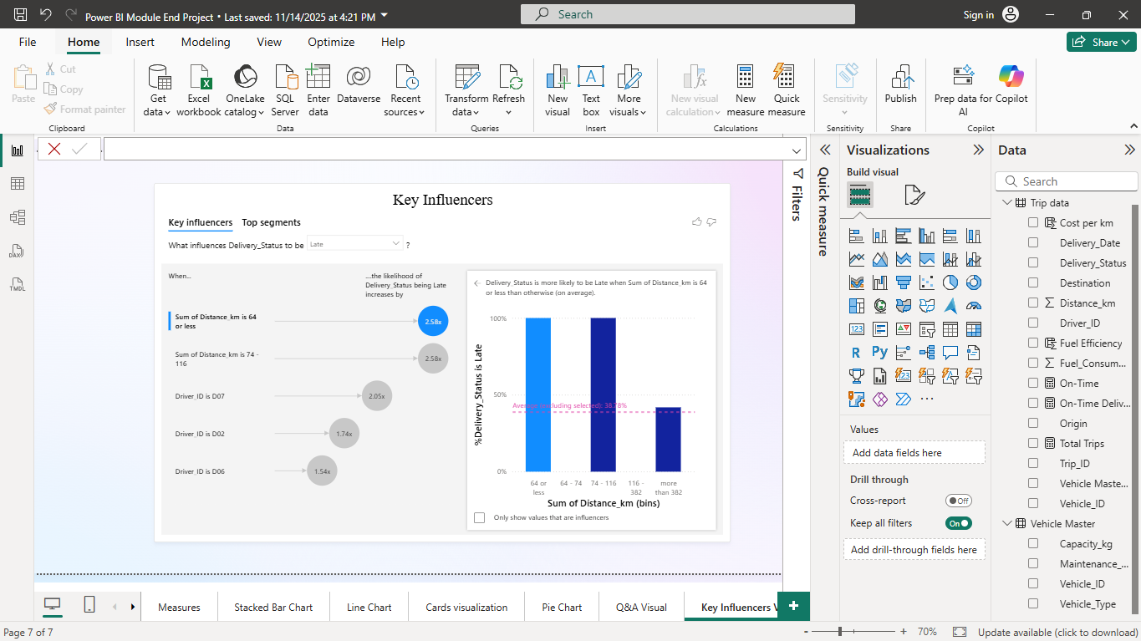
❖ Decomposition Tree (AI Visual):
➢ Analyze Cost per km → explained by Vehicle Type, Maintenance_cost,
and Distance_km.
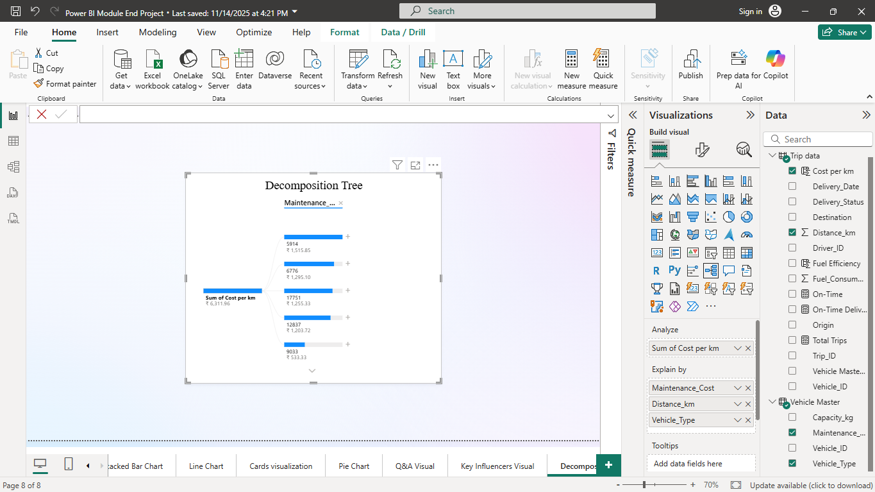

A transport operations dashboard to optimize routes and fleet usage.
